1. Create a inheritance class. (Super class as Vehicle and 2 subclasses Car and Bike and inherit the Vehicle class methods)
2. Depict programmatically the Method overloading and Method overriding concepts.
3. Create an abstract class and extend that class and try to create the object of the abstract class in a program and execute.

ANSWERS

1.



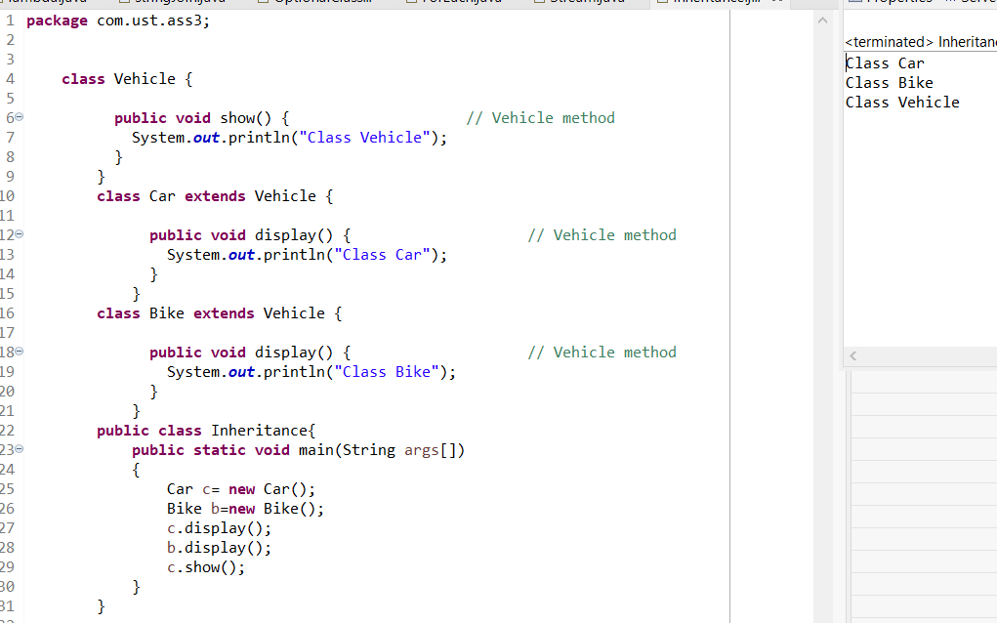

2.



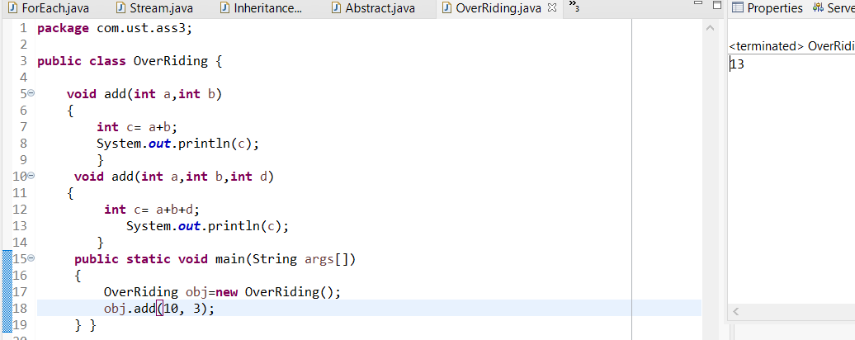

3.



